There are 10 blanks, numbered 29 to 38, in the passage below. From the list of words  
given, choose the most suitable word for each blank. Write its fetter (A to Q) in the blank.  
The letters (1) and (O) have been omitted to avoid confusion during marking. (10 marks)

EACH WORD CAN BE USED ONLY ONCE.  
ne

(Aja (D) at (6) is (K) than * (N) will  
  
{B) are (E) by {H) only {L) the (P) with  
(C) around (F) despite (J) since (M) to (Q) would  
ener

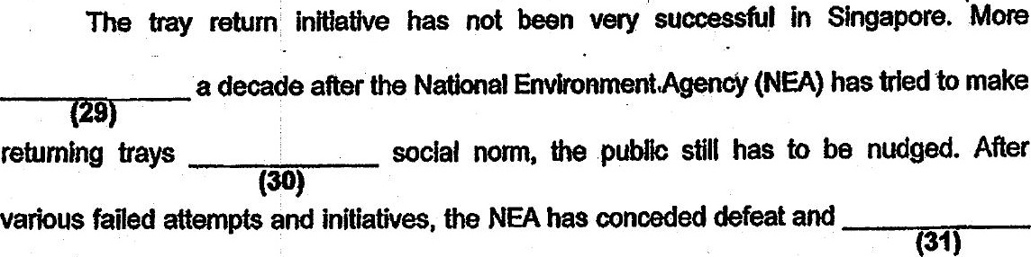

hitting customers where ft hurts — through thelr wallets.

Over the next few years, up to twenty hawker centres managed (EMP Ty  
the NEA could start charging for food trays. This is in tandem _________ the  
introduction of automated tray-retum systems and centralised dish-washing services

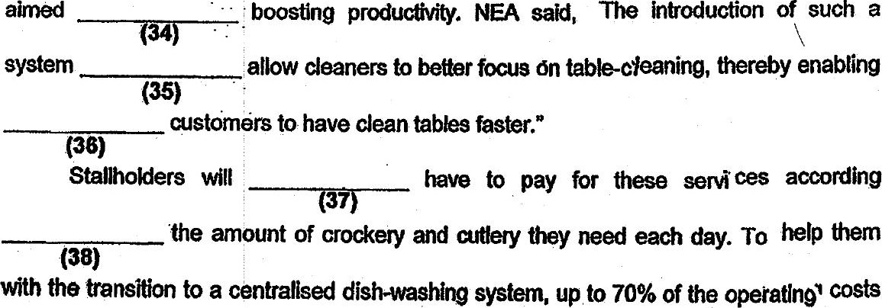

will De co-funded by NEA for an initial period of two years.

Adapted from hitps//www.todayoniine.com/singapore/